Rolling Hills Subdivision
Client: East West Partners Co.
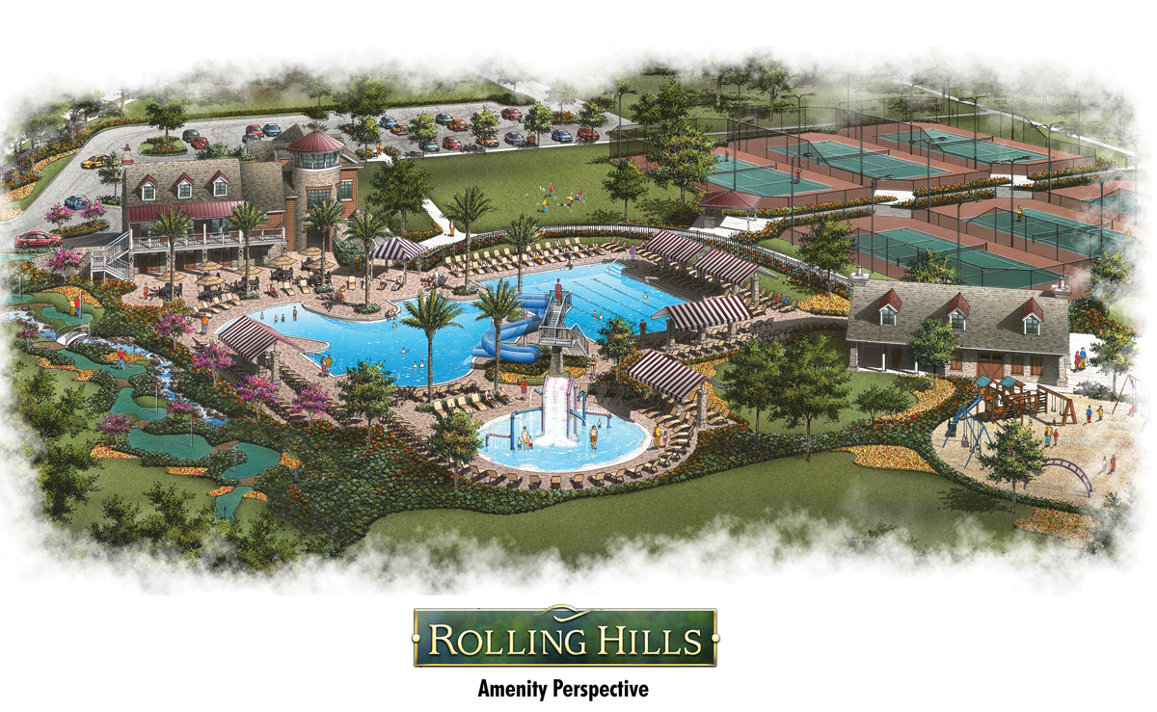

Rolling Hills is a 560 acre, 761 lot subdivisions located on County Road 739B in Lake Asbury, Florida. The design of the subdivisions was to incorporate the natural contour of the land with its seventy feet of fall across the property leading it down to a lush preservation land. In addition to the traditional subdivision design, Hadden and Land Engineering Teamed up with Basham and Lucus Design Group to include an all inclusive amenity area.

Services Provided:

Concurrency
Conceptual Layout
Master Drainage Design
Master Utility Design
Roadway Design
Lot Grading
County Road Expansion
Lift Stations

Project Manager:
W. Scott Land, P.E.

